School of Computer Science Engineering &

Information Science

Report on

Analysis and Visualization of Malnutrition Dataset

Date : 15-05-2024

Time:11.00AM-12.50PM

Course: Data Analysis And Visualization

Course Code: CSE2015 Activity Conducted By.

|  |  |  |
| --- | --- | --- |
| S.No. | Roll No. | Name |
| 1 | 20211IST0008 | DARSHAN.R.N |
| 2 | 20211IST0010 | TEJASHWIMI.K.T |
| 3 | 20211IST0012 | SATHYA.R |

Topic : Analysis and Visualization of Malnutrition Dataset

Abstract:

Malnutrition remains a significant global health challenge, affecting millions of individuals, particularly in low- and middle-income countries. This condition encompasses both undernutrition and overnutrition, leading to a spectrum of health issues ranging from stunted growth and weakened immunity to obesity and related non-communicable diseases. Key factors contributing to malnutrition include food insecurity, poverty, inadequate healthcare, and poor dietary practices. Vulnerable populations, such as children, pregnant women, and the elderly, are disproportionately impacted. Interventions to combat malnutrition must be multifaceted, involving improvements in food systems, healthcare access, nutritional education, and socioeconomic policies. Recent advancements in public health strategies, including community-based nutrition programs and international collaborations, offer promising avenues to mitigate malnutrition's effects. However, sustained efforts and innovative approaches are essential to address the underlying determinants of malnutrition and ensure optimal health outcomes for all individuals.

Introduction:

Malnutrition is a common health problem and occurs when you are not eating enough of the right foods or have a problem absorbing nutrients from food. This means you are not getting all the nutrients such as proteins, vitamins and minerals that you need. Despite efforts to address malnutrition, it remains a pressing global health issue.

The aim of this project is to analyze a comprehensive dataset on malnutrition indicators across countries and regions, identify key trends and patterns, and visualize the data to provide insights for policymakers, researchers, and organizations working to combat malnutrition.

The analysis will focus on understanding the prevalence of malnutrition, its distribution, contributing factors, and the effectiveness of interventions, with the goal of informing targeted strategies to reduce malnutrition and improve nutrition outcomes worldwide.

Problem Statement:

Malnutrition refers to deficiencies, excesses, or imbalances in a person's intake of energy and/or nutrients. The term malnutrition addresses 3 broad groups of conditions: undernutrition, which includes wasting (low weight-for-height), stunting (low height-for-age) and underweight (low weight-for-age). People with protein-energy undernutrition are often visibly emaciated. Children may have stunted growth and development. One of the first systems to begin to shut down is the immune system. This makes undernourished people highly prone to illness and infection and slower to recover.

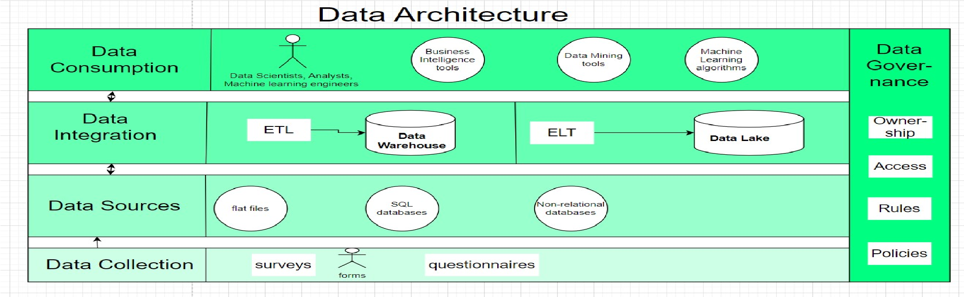Architecture:

For analyzing and visualizing malnutrition data across the globe, we can consider the following model of architecture:

1. Data Collection: Gather datasets from reliable sources such as the World Health Organization (WHO), UNICEF, World Bank, and other reputable organizations. Include data on various aspects of malnutrition, including prevalence rates, causes, impacts, and interventions.
2. Data Preprocessing: Clean the data by removing duplicates, correcting errors, and handling missing values. Convert the data into a suitable format for analysis and visualization.
3. Data Integration: Combine data from different sources and formats into a unified dataset for comprehensive analysis.
4. Data Analysis: Use statistical analysis techniques to explore the data and identify patterns, trends, and correlations related to malnutrition. This can include descriptive statistics, inferential statistics, and machine learning algorithms for predictive analysis.
5. Data Visualization: Create visualizations such as charts, graphs, maps, and dashboards to present the findings of the analysis. Use interactive visualizations to allow users to explore the data dynamically.
6. Insights Generation: Extract meaningful insights from the data analysis to understand the factors contributing to malnutrition and to inform decision-making processes.
7. Model Deployment: Deploy the data visualization models on platforms that can reach a wide audience, such as websites, mobile apps, or public data portals.
8. Feedback Loop: Collect feedback from users and stakeholders to continuously improve the data visualization models and analysis techniques.
9. Collaboration and Sharing: Facilitate collaboration and sharing of the data and insights with other researchers, policymakers, and organizations working in the field of malnutrition.
10. Ethical Considerations: Ensure that the data analysis and visualization processes adhere to ethical standards, including data privacy and confidentiality.

By following this architecture, we can effectively analyze and visualize malnutrition data to gain insights and drive action towards addressing this global challenge.

Outcomes:

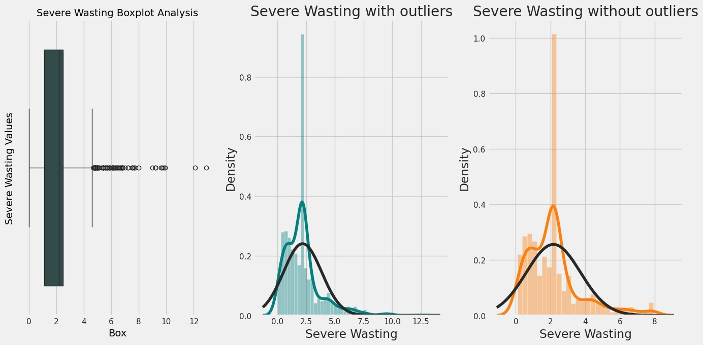

This code appears to be analyzing outliers in a dataset for columns related to malnutrition indicators such as 'Severe Wasting' .

* + Boxplotcolumns: This is a list containing the names of columns for which boxplots and outlier analysis will be performed.
  + for cols in boxplotcolumns: This iterates over each column name in boxplotcolumns

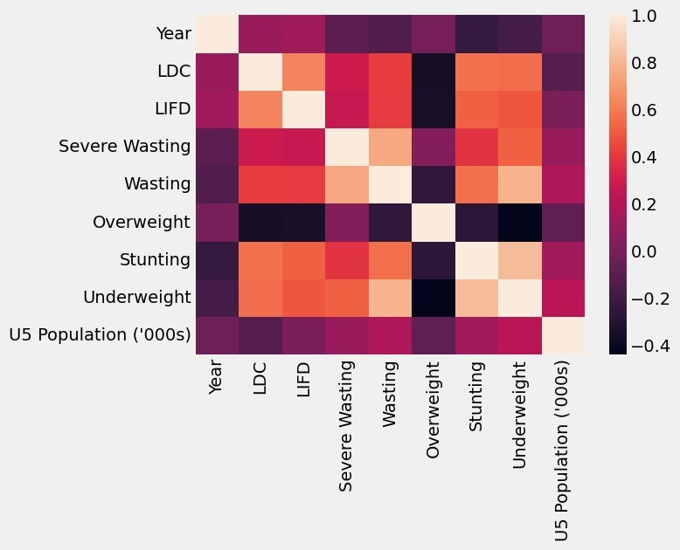

The x and y-axis of the heatmap represent the column names of the dataset. Each cell in the heatmap represents the correlation coefficient between the corresponding pair of columns.

The color of each cell indicates the strength and direction of correlation: positive correlation is typically represented by warmer colors (e.g., red), while negative correlation is represented by cooler colors (e.g., blue). A correlation coefficient close to 0 indicates no correlation.

By visualizing the correlation matrix as a heatmap, you can quickly identify patterns of correlation between different variables in the dataset. This helps in understanding the relationships between variables and identifying potential multicollinearity issues in regression analysis, among other things.

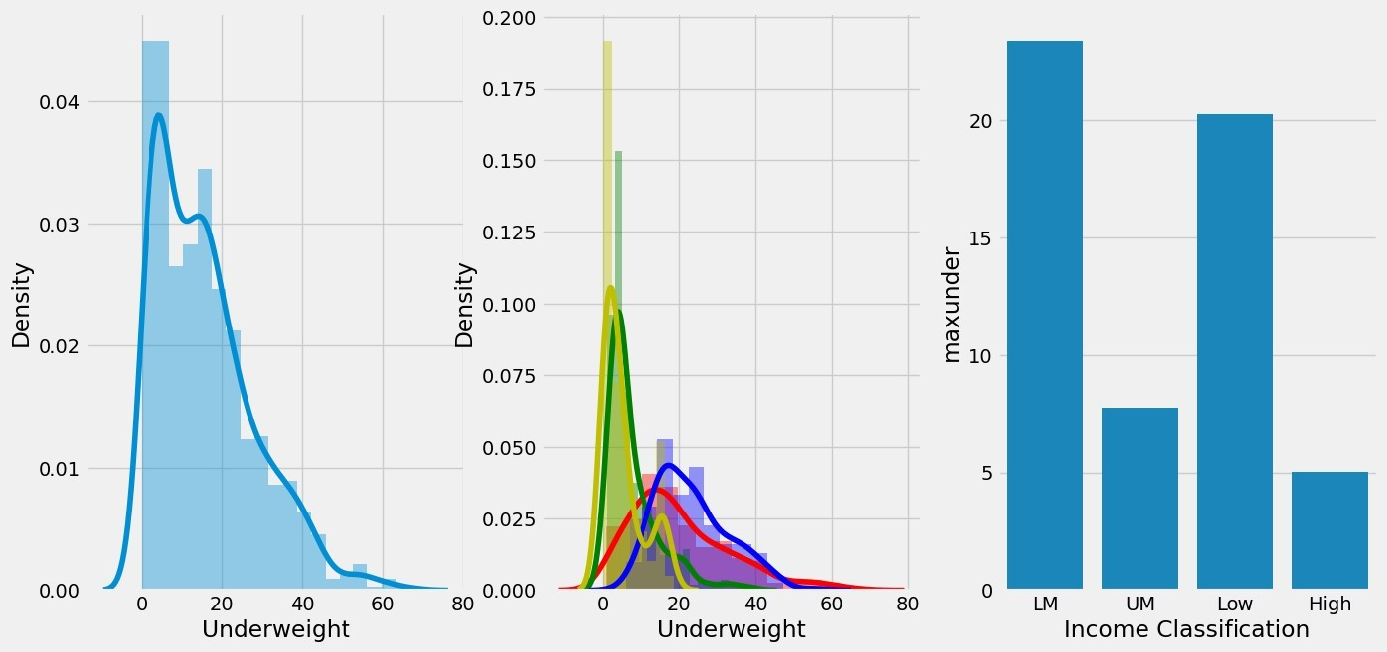

This code generates a figure with three subplots arranged horizontally (side by side).Overall, this code visualizes the distribution of the 'Underweight' variable and compares it across different levels of 'Income Classification' using distribution plots and a bar plot.

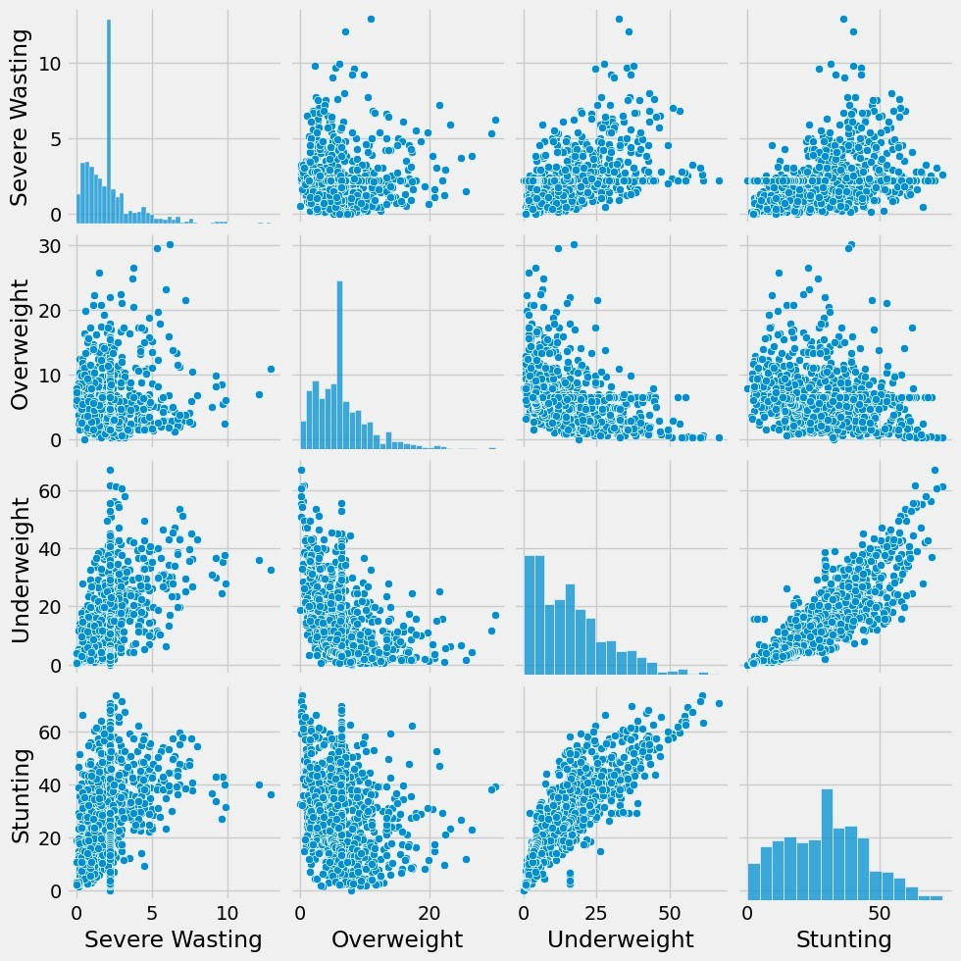

The pairplot displays scatterplots for each combination of variables selected. Along the diagonal, it shows histograms of each individual variable. Each point on the scatterplot represents one observation (or row) in the dataset, and the position of the point corresponds to the values of the two variables being compared.

By visualizing the pairwise relationships between these variables, you can quickly identify patterns, correlations, and potential outliers in the data. For example, you can assess whether there's a linear relationship between variables, check for the presence of clusters, or observe the distribution of each variable individually along the diagonal.

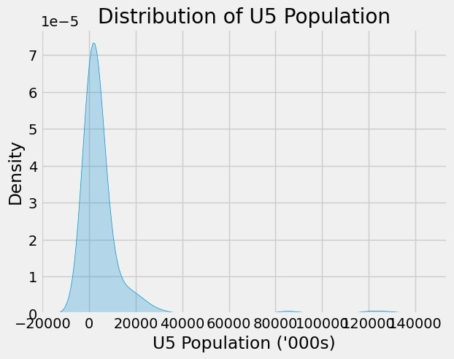

The KDE plot is a way to visualize the probability density function of a continuous random variable. It provides a smoothed estimate of the probability density function based on the observed data points. In this case, the KDE plot shows the distribution of the 'U5 Population ('000s)' variable, allowing you to visualize the shape and spread of the data. The shaded area under the curve represents the estimated probability density at each point along the x-axis.

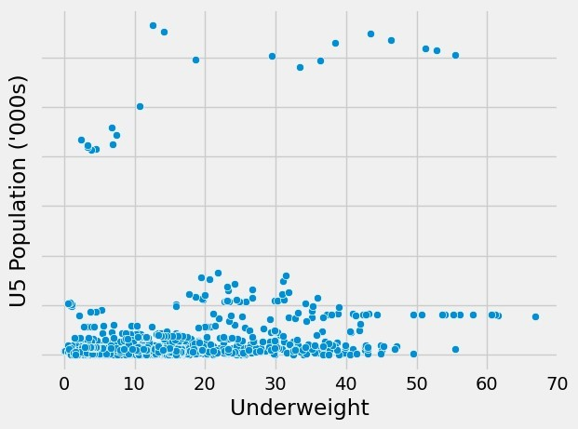

The scatter plot visually represents the relationship between the 'Underweight' variable and the 'U5 Population ('000s)' variable. Each point on the plot represents an observation in the dataset, where the x-coordinate is the value of 'Underweight' and the y-coordinate is the value of 'U5 Population ('000s)'. This allows you to visualize any potential relationship or pattern between these two variables.

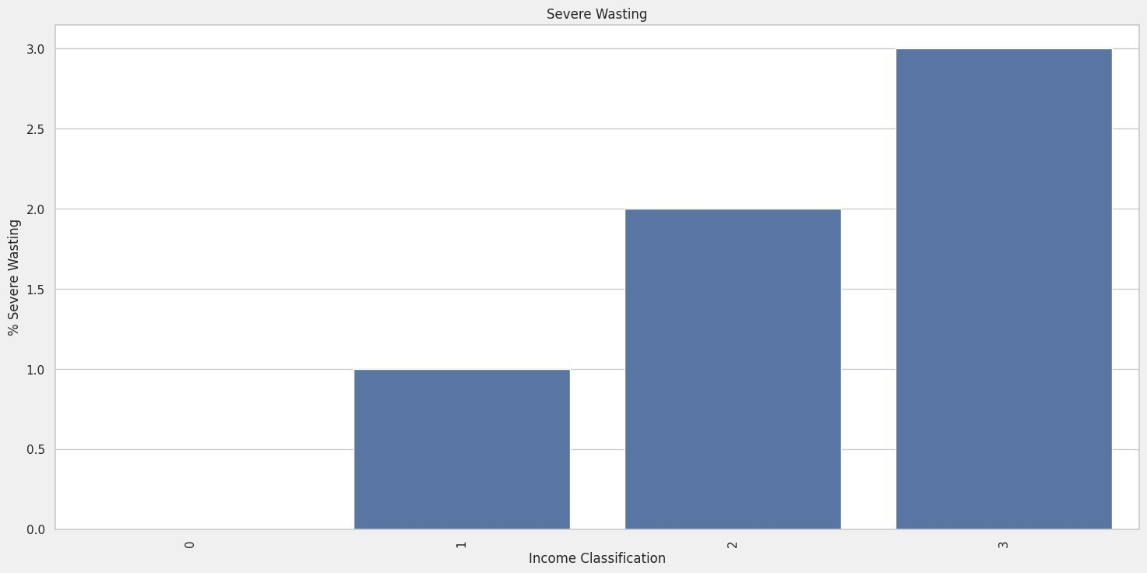

Bar plot using Seaborn's barplot function.The resulting plot shows the average severity of wasting (% Severe Wasting) for each income classification group. Each bar represents a different income classification, and its height indicates the average severity of wasting for that group

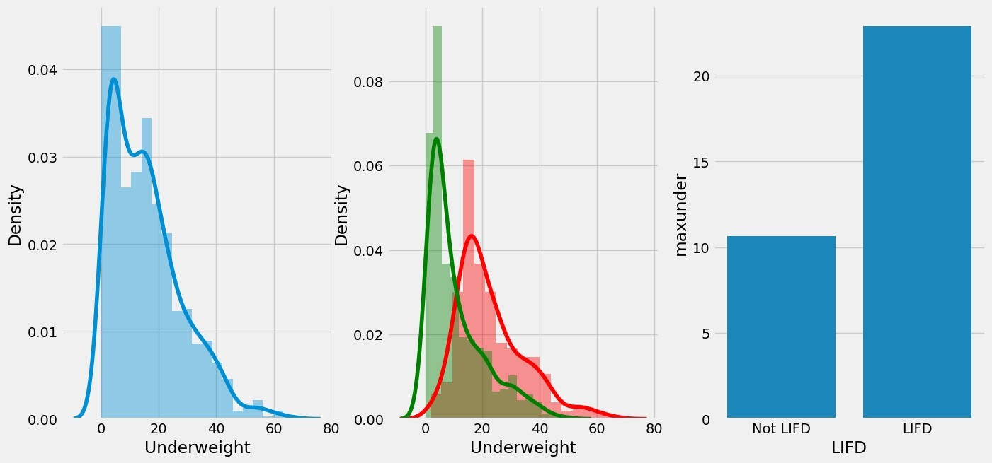

This output generates a figure with three subplots arranged horizontally (side by side).

It creates density plots (using sns.distplot) for the 'Underweight' column on the first and second subplots, differentiated by the 'LIFD' status. The first subplot shows the distribution of 'Underweight' for the entire dataset, while the second subplot shows the distribution only for rows where 'LIFD' is 1 (in red) and 0 (in green).

The final output visualizes the distribution of 'Underweight' across different 'LIFD' groups using density plots and bar plots

Results:

The CIAF status of children was found to be positively associated with the male gender, the potency of contracting a disease, and multiple births. However, it was negatively associated with family wealth quartiles, parental level of education, place of residence, unemployment status of mothers, improved sanitation, media exposure, and survey years. Moreover, the study revealed significant spatial variations on the level of CIAF among administrative zones.

Benefits of Data analysis and visualization of Malnutrion dataset:

Data analysis and visualization of malnutrition datasets offer numerous benefits across various domains:

1. Insight Generation: By analyzing malnutrition data, one can gain insights into the prevalence, distribution, and determinants of malnutrition across different demographics, regions, and socioeconomic groups.
2. Policy Formulation: Governments and policymakers can leverage data analysis to formulate evidence-based policies and interventions aimed at addressing malnutrition. For instance, identifying high-risk areas or populations can help in targeting resources effectively.
3. Resource Allocation: Analysis of malnutrition data can inform resource allocation decisions, such as directing funding towards regions or communities with the highest prevalence of malnutrition.
4. Monitoring and Evaluation: Data analysis allows for ongoing monitoring and evaluation of malnutrition interventions. By tracking key indicators over time, stakeholders can assess the effectiveness of programs and make necessary adjustments.
5. Early Warning Systems: Analysis of trends in malnutrition data can serve as an early warning system for identifying emerging issues or areas where intervention is needed before situations escalate.
6. Research and Innovation: Researchers can use malnutrition data to identify patterns, correlations, and risk factors associated with malnutrition, leading to the development of new approaches for prevention and treatment.
7. Public Awareness and Advocacy: Visualizations of malnutrition data can effectively communicate the severity of the issue to the public and policymakers, fostering greater awareness and advocacy for action.
8. Healthcare Planning: Healthcare providers can use malnutrition data to plan and allocate resources for the treatment and management of malnutrition-related health conditions.
9. Education and Training: Malnutrition data analysis can inform educational programs and training initiatives for healthcare professionals, policymakers, and community workers involved in addressing malnutrition.
10. International Collaboration: Data sharing and collaborative analysis of malnutrition data at the international level can facilitate knowledge exchange, best practice sharing, and coordinated efforts to combat malnutrition globally.

Conclusion:

In conclusion, data analysis and visualization of malnutrition datasets offer a multifaceted approach to understanding, addressing, and mitigating the impact of malnutrition globally. By leveraging the power of data, stakeholders across various sectors can gain valuable insights into the prevalence, determinants, and consequences of malnutrition, ultimately leading to more effective policies, interventions, and resource allocation strategies. Through ongoing monitoring, evaluation, and research, data analysis serves as a catalyst for innovation and continuous improvement in the fight against malnutrition. Moreover, the visualization of malnutrition data not only enhances communication and awareness but also fosters collaboration, advocacy, and collective action on a local, national, and international scale. Embracing data-driven approaches empowers societies to tackle malnutrition comprehensively, ensuring healthier and more resilient communities now and in the future.